SUPPLEMENTARY MATERIAL: APPENDIX
Mohammed Muddassir Ali Uzair. Reinforcement Learning and Agentic AI in Cybersecurity Trade-off Analysis. Master's thesis, Cleveland State University, Fall 2026.
This appendix accompanies the thesis. Tables are numbered A.1 to A.27, figures A1 to A5, and equations (A.1) to (A.39); references to Tables I to XIV and Figures 1 to 10 are to the main text of the thesis. Sections: A1 Implementation and reproducibility evidence; A2 Model equations; A3 Parameters, data sources, and units; A4 Calibration results; A5 Model validation tests; A6 Reinforcement-learning configuration; A7 Additional results; A8 Sensitivity and trade-off results; A9 Reproduction protocol; A10 Guide to tables and figures; A11 Code and data.
A1. Implementation and Reproducibility Evidence

Table A.1
Implementation and Reproducibility Evidence
Evidence Item | Location in Research Package
Environment, observation and SD prior | thesis_rl_study/hybrid_vm/env.py
PPO agents M1, M2 and M2-P | thesis_rl_study/hybrid_vm/ppo.py
Experiment runner (Twin-Testing, E1, E2, E3) | thesis_rl_study/run_study.py
Statistics and figures | thesis_rl_study/analysis.py and analysis_balanced.py
Automated test suite (ten checks) | thesis_rl_study/tests/test_model.py
Trained checkpoints and checkpoint manifest | thesis_rl_study/results/twin/
Result files | thesis_rl_study/results/ and results_balanced/
Verification of a rerun | thesis_rl_study/verify_rl.py
As-of data panel (NVD, EPSS, KEV) | thesis_rl_study/panel.npz
SD calibration, sensitivity and Pareto analyses | thesis_sd/src/01 to 08
SD verification | thesis_sd/verify.sh
Vensim model | thesis_sd/vensim/vulnerability_sd_model.mdl
Software environment | Dockerfile in each package
Source: Inventory of the two archived packages.

The README of each package gives the exact commands to run the tests, reproduce every experiment and verify the results. Completed stages are skipped rather than overwritten. Raw source manifests retain URLs, hashes, and retrieval metadata.

Experimental Scale

The study trained 90 agents for Twin-Testing and Experiment 1 (864,000 transitions), 30 longer runs for Experiment 3 (2,880,000 transitions) and 90 agents for the exploratory reward analysis (864,000 transitions), and evaluated 14,100 Twin-Testing, 6,720 E2A and 13,020 E2B test episodes.

Verification Test Results

The reinforcement-learning package carries ten automated checks, listed in Section §A9, all of which pass.

Source Data References

FIRST. EPSS data and frequently asked questions. https://www.first.org/epss/data

NIST. NVD vulnerability API documentation. https://nvd.nist.gov/developers/vulnerabilities

CISA. Official KEV data mirror. https://github.com/cisagov/kev-data

U.S. Department of Health and Human Services, Office for Civil Rights. HIPAA breach report portal, under-investigation and archive CSV exports, retrieved October 1, 2026. https://ocrportal.hhs.gov/ocr/breach/breach_report_hip.jsf
A2. Model Equations

This appendix lists every equation of the System Dynamics model, the decision rules, the calibration procedures, the fit statistics, the sensitivity and Pareto analyses, and the statistical tests, so that the study can be reproduced from the thesis alone. Every equation is a native Word equation object. Symbols are defined in Section §A3, Table A.3. Time t is measured in days, and all stocks are integrated with a daily Euler step.

Table A.2
Equation Guide: What Each Equation Computes, How It Is Solved, and Where It Is Implemented
Equation | What it computes | How it is solved or computed | Implemented in
(1) | Constrained Markov decision process: states, actions, transitions, reward, constraints, horizon | Framing; solved approximately by the policies of Chapter III with action masking | env.py; ppo.py
(2), (10), A.13 | Action preferences of residual PPO, placebo and model-free PPO | Computed at every decision; network weights learned by PPO-Clip with Adam (Schulman et al., 2017) | ppo.py (Agent.logits, Agent.update)
(3), A.1–A.2 | Backlog stock and its three FIFO queues | Difference equation updated once per day (explicit Euler step of one day) | env.py; sdmodel.py
A.3–A.4 | Daily arrivals | Poisson draws in the RL experiments; negative-binomial draws with weekday pattern and trend in the reference model | env.py; sdmodel.py
(4), A.5–A.6 | Threat-weighted exposure from as-of EPSS | Summed over open items each day after patching; EPSS from the previous day's file | env.py (Episode.exposure)
(5), A.7–A.8 | Effective capacity with availability and emergency-work feedback | Computed at the start of each day and rounded down to whole patches; zero on maintenance days | env.py; sdmodel.py
(6)–(7), A.9–A.10 | Availability loss and availability stock | Explicit daily update, clipped to the interval from 0.6 to 1 | env.py; sdmodel.py
(8), A.11 | Reward | Computed each step; reference scales are 99th percentiles under SD-only on the training partition | env.py; run_study.py (compute_scales)
(9), A.12 | SD prior cost of each action | Closed form for all 35 actions at every decision; SD-only takes the lowest cost | env.py (sd_cost, sd_logits)
A.14–A.17 | Outcome measures of an episode | Computed at the end of each test episode | env.py (Episode.metrics)
A.18–A.20 | Mismatch penalty, repair ratio, area under the learning curve | Computed from seed-level results; AULC by the trapezoid rule | analysis.py
(11), A.21–A.22 | Least-squares calibration objective | Minimised by differential evolution (Storn and Price, 1997), seeded | 02_calibrate_arrivals.py; 03–05
(12), A.23 | Bayesian posterior of the arrival model | Sampled by affine-invariant ensemble MCMC (Foreman-Mackey et al., 2013), seeded | 02_calibrate_arrivals.py
(13), A.24 | Severity shares | Closed-form conjugate Dirichlet posterior | 03_calibrate_severity_kev.py
(14), A.25 | KEV escalation with censoring | Likelihood maximised by differential evolution and sampled by MCMC | 03_calibrate_severity_kev.py
(15), A.26–A.28 | Two-stream remediation survival and capacity | Differential evolution and Bayesian MCMC on the logit scale | 04_calibrate_remediation.py
(16) | Two-stream remediation stocks | Integrated with daily Euler steps | 05_run_and_compare.py
A.29–A.30 | Effective capacity and enterprise scaling | Differential evolution against the 15-day remediation share; scaling ratio computed directly | 05_run_and_compare.py
A.31–A.33 | Fit statistics (Theil, MAPE, R-squared) | Computed directly from simulated and actual series | common.py
A.34–A.35 | Sobol indices | Saltelli estimators (Saltelli et al., 2010) with SALib (Herman and Usher, 2017) | 07_sobol.py
A.36–A.37 | Pareto dominance and frontier | Pairwise dominance check over all configurations | 08_pareto.py
A.38–A.39 | Rank-biserial effect and Holm adjustment | Computed directly from paired seed differences; Holm over the four confirmatory tests | analysis.py (rank_biserial, holm)
Source: File names refer to thesis_rl_study (env.py, ppo.py, run_study.py, analysis.py) and thesis_sd/src.
B.1 Stocks, Flows, and Auxiliaries

The model has two stocks on a daily time step. Backlog is held in three first-in-first-out severity queues; the reference SD model draws arrivals from the calibrated negative-binomial process, and the reinforcement-learning experiments from a Poisson process with mean three per day.
$B_{t+1}=B_{t}+N_{t}−P_{t}$ (A.1)
$B_{t}=Q_{t}^{crit}+Q_{t}^{high}+Q_{t}^{med}$ (A.2)
$N_{t}∼Poisson\left(3\right) \text{(RL experiments)}$ (A.3)
$N_{t}∼NB\left(μ_{t},k\right), μ_{t}=λ e^{gt/90} s_{dow\left(t\right)} \text{(reference model)}$ (A.4)
$q_{i,t}={EPSS}_{i}\left(t−1\right)$ (A.5)
Et=i∈Ut​min1,h qi,t wi (A.6)
$f_{t}=min\left(0.25,\frac{hB_{t}}{B_{t}+30}\right)$ (A.7)
$c_{t}^{eff}=min\left(4,\left\lfloor 4A_{t} r \left(1−f_{t}\right)\right\rfloor \right), c_{t}^{eff}=0\text{ on days 7 and 14}$ (A.8)
$L_{t}=κ_{P}{\hat{P}}_{t}+κ_{E}{\hat{E}}_{t}, κ_{P}=0.004P^{*}, κ_{E}=0.006E^{*}$ (A.9)
$A_{t+1}=clip\left(A_{t}+α\left(1−A_{t}\right)−κ_{P}{\hat{P}}_{t}−κ_{E}{\hat{E}}_{t}, 0.6, 1\right)$ (A.10)
$r_{t}=−\left[{\hat{E}}_{t}+λ{\hat{B}}_{t+1}+μ{\hat{L}}_{t}\right], \hat{x}=x/x^{*}$ (A.11)
B.2 Decision Rules

The SD prior scores every feasible action a by five days of holding cost on the post-action state plus its availability cost (A.12). Residual PPO, the placebo agent and model-free PPO form their action logits as in (A.13); infeasible actions are masked before the softmax, and evaluation takes the highest-logit action.
$J\left(a\right)=H_{p}\left[\hat{E}′_{a}+λ\hat{B}′_{a}+μκ_{E}\hat{E}′_{a}/L^{*}\right]+ωμH_{p}κ_{P}\hat{P}\left(a\right)/L^{*}$ (A.12)
$z_{t}=z_{t}^{SD}+2tanhf_{θ}\left(o_{t}\right) \text{(M2)}, z_{t}=2tanhf_{θ}\left(o_{t}\right) \text{(M2-P)}, z_{t}=f_{θ}\left(o_{t}\right) \text{(M1)}$ (A.13)
B.3 Outcome Measures

The outcome measures are computed per 15-day episode ($H=15$) over all n items; $a_{i}$ is the arrival day (−1 for the initial backlog) and $d_{i}$ the remediation day. The reference System Dynamics model (Table A.12 and Figures 9–10) reports availability loss instead as the average shortfall of availability below one over the episode; the two measures are not compared with each other.
$J=\sum_{t=0}^{H−1}{E_{t}} \text{(cumulative exposure index)}$ (A.14)
d=1ni​di−ai+1remediatedH−aiunresolved (A.15)
$U=\frac{\left|\{i:\text{unresolved at }H\}\right|}{n}$ (A.16)
$Λ=\sum_{t=0}^{H−1}{\left(0.004P_{t}+0.006E_{t}\right)} \text{(availability loss)}$ (A.17)
For the robustness and learning experiments, $J\left(δ\right)$ is the mean cumulative exposure at prior or environment mismatch $δ$, and $J\left(k\right)$ the mean validation exposure after k training transitions:
${MP}_{π}\left(δ\right)=\frac{J_{π}\left(δ\right)−J_{π}\left(0\right)}{J_{π}\left(0\right)} \text{(mismatch penalty)}$ (A.18)
$RR\left(δ\right)=\frac{J_{B4}\left(δ\right)−J_{M2}\left(δ\right)}{J_{B4}\left(δ\right)} \text{(residual repair ratio)}$ (A.19)
${AULC}_{π}=\frac{1}{k_{max}−k_{min}}\int_{k_{min}}^{k_{max}}{J_{π}}\left(k\right) dk \text{(trapezoid rule)}$ (A.20)
B.4 Calibration

θDE=argminθ∈Θt​ytθ−yt2 (A.21)

$v=x_{r_{1}}+F\left(x_{r_{2}}−x_{r_{3}}\right), u_{j}=\left\{\begin{matrix}v_{j} & \text{if }U_{j}<CR \\ x_{j} & \text{otherwise}\end{matrix}\right.$ (A.22)

$p\left(θ∣y\right)∝p\left(y∣θ\right)p\left(θ\right)$ (A.23)

$π∣n∼Dirichlet\left(1+n_{crit}, 1+n_{high}, 1+n_{med}, 1+n_{miss}\right)$ (A.24)

LπK,τK=i∈K​πKτKe−Li/τKi∉K​1−πK1−e−Ti/τK, η=πKτK (A.25)

$S\left(t\right)=f e^{−t/τ_{f}}+\left(1−f\right)e^{−t/τ_{s}}$ (A.26)

$logit\left(y_{j}\right)∼N\left(logit\left(1−S\left(t_{j}\right)\right), σ^{2}\right)$ (A.27)

$\overset{‾}{ℓ}=fτ_{f}+\left(1−f\right)τ_{s}, C_{month}=\frac{30}{\overset{‾}{ℓ}}$ (A.28)

$\hat{c}=arg\min_{c}{\left({\hat{F}}_{15}\left(c\right)−F_{15}^{obs}\right)}^{2}, F_{15}^{obs}=1−S\left(15\right)$ (A.29)

$λ=ϕ \overset{‾}{y}, ϕ=\frac{3}{357.5}=0.0084$ (A.30)

B.5 Goodness-of-Fit Statistics

U=1nt​St−At21nt​St2+1nt​At2 (A.31)

$U^{M}=\frac{{\left(\overset{‾}{S}−\overset{‾}{A}\right)}^{2}}{MSE}, U^{S}=\frac{{\left(s_{S}−s_{A}\right)}^{2}}{MSE}, U^{C}=\frac{2\left(1−r\right)s_{S}s_{A}}{MSE}$ (A.32)

MAPE=100nt​St−AtAt, R2=r2 (A.33)

$S_{t}$ is the simulated and $A_{t}$ the actual value, $s_{S}$ and $s_{A}$ are their standard deviations, and $r$ is their correlation; $U^{M}+U^{S}+U^{C}=1$.

B.6 Sensitivity, Pareto, and Statistical Tests

$S_{i}=\frac{V_{X_{i}}\left(E_{X_{∼i}}\left[Y∣X_{i}\right]\right)}{V\left(Y\right)}, S_{T_{i}}=\frac{E_{X_{∼i}}\left[V_{X_{i}}\left(Y∣X_{∼i}\right)\right]}{V\left(Y\right)}$ (A.34)

${\hat{S}}_{i}=\frac{\frac{1}{N}\sum_{j=1}^{N}{f}{\left(B\right)}_{j}\left(f{\left(A_{B}^{\left(i\right)}\right)}_{j}−f{\left(A\right)}_{j}\right)}{\hat{V}\left(Y\right)}, {\hat{S}}_{T_{i}}=\frac{\frac{1}{2N}\sum_{j=1}^{N}{{\left(f{\left(A\right)}_{j}−f{\left(A_{B}^{\left(i\right)}\right)}_{j}\right)}^{2}}}{\hat{V}\left(Y\right)}$ (A.35)

$F\left(x\right)≺F\left(y\right)⇔F_{j}\left(x\right)≤F_{j}\left(y\right) ∀j \text{and} F_{j}\left(x\right)<F_{j}\left(y\right) \text{for some} j$ (A.36)

$P=\left\{x∈X: ∄ y∈X, F\left(y\right)≺F\left(x\right)\right\}$ (A.37)

W+=j: dj>0​rankdj, rrb=W+−W−W++W− (A.38)

${\tilde{p}}_{\left(j\right)}=\max_{l≤j} min\left\{1, \left(m−l+1\right)p_{\left(l\right)}\right\}, m=4$ (A.39)
Confirmatory tests. H1, H2 (threat), H2 (asset) and H3 are one-sided Wilcoxon signed-rank tests on seed-level values, Holm-adjusted at $α=0.05$ as one family. Each reports the median paired difference, a bootstrap 95% interval of the mean difference (10,000 resamples) and the paired rank-biserial correlation $r=\frac{W^{+}−W^{−}}{W^{+}+W^{−}}$. The mismatch penalty is $MP\left(δ\right)=\frac{J\left(δ\right)−J\left(0\right)}{J\left(0\right)}$, the repair ratio $RR\left(δ\right)=\frac{J_{B4}\left(δ\right)−J_{M2}\left(δ\right)}{J_{B4}\left(δ\right)}$, and AULC is the trapezoid integral of validation exposure over training transitions divided by their range.

A3. Parameters, Data Sources, and Units

Table A.3 states, for every parameter of the System Dynamics model and the decision rules, the value used, where it comes from, why it was chosen, and how its influence was tested. Parameters are of three kinds: measured from real data (calibrated), taken from published literature, or design assumptions. Design assumptions are not hidden; each is either varied in the Sobol analysis (Section §A8) or perturbed in a Twin-Testing stress condition. Table A.4 lists the empirical datasets and their provenance.

Table A.3
Model Parameters: Value, Source, Rationale, and Test
Parameter | Value | Source | Rationale | How Tested
NVD disclosure rate | 357.5 CVEs/day (Jun 17–Sep 14, 2026) | NVD (NIST, n.d.), measured | Real inflow of new vulnerabilities | Out-of-sample, 22 days (Table A.11)
Enterprise relevance $ϕ$ | 0.0084 ($λ=3$/day) | Design assumption | Small-enterprise scale used in the RL experiments | Sobol, $λ∈\left[1.5,4.5\right]$
Weekday factors, trend $g$, dispersion $k$ | Table A.6 | NVD; Bayesian NB (Eq. 12) | Reproduces real burstiness | Sobol, $k∈\left[1,10\right]$; posterior propagation
Severity thresholds | Critical $≥9.0$; High 7.0–8.9 | CVSS v3.1 qualitative scale (FIRST) | Standard severity bands define queues | —
Missing-score imputation | 7.3 | Training-period median | Avoids look-ahead | Re-extraction gives same median
Queue shares $π$ | 12.5 / 51.2 / 36.3% | NVD; Dirichlet (Eq. 13) | Routes arrivals to queues | Weekly stability (Figure 5a)
Threat score $p$ | EPSS (RL runs); Beta, mean 0.09 (reference model) | Jacobs et al. (2021, 2023); assumption | Exploitation probability | Sobol, $\overset{‾}{p}∈\left[0.03, 0.20\right]$
Threat multiplier $h$ | 1 (2 under stress) | Design (Twin-Testing) | Scales exploitation pressure | Threat stress; Sobol [0.5, 2]
KEV hazard $η$ | $1.25×{10}^{−4}$ per day | CISA KEV + NVD; Eq. 14 | Threat escalation inflow | Kaplan–Meier check; Sobol
Asset weights $w$ | Uniform(0.5, 1.5) | Design assumption; risk-based prioritization (Souppaya and Scarfone, 2022) | Relative asset criticality | Asset stress (×2); Sobol scale [0.5, 2]
Daily capacity $c$ | 4 (RL); not identified (Chapter IV) calibrated | Kenna Security & Cyentia Institute (2019); DE (Eq. 17) | Remediation throughput | Resource stress (×0.6); Sobol [2, 4.5]
Remediation streams $f$, $τ_{f}$, $τ_{s}$ | 0.40, 33.5 d, 448 d | Kenna Security & Cyentia Institute (2019); DE + Bayes | Long-tailed remediation times | Independent 1-in-10 monthly capacity
Initial backlog $B_{0}$ | 8 | Design assumption | Small-enterprise starting state | Sobol [4, 16]
Recovery $α$ | 0.12 per day | Design; first-order adjustment time $1/α≈8$ days (Sterman, 2000) | Goal-seeking recovery (loop B4) | Sobol [0.06, 0.24]
Disruption $β_{1}$, $β_{2}$ | 0.004, 0.006 | Design assumption | Bound availability above 0.6 at maximum load | Sobol [0.002, 0.008], [0.003, 0.012]
Availability floor | 0.60 | Engineering bound | Operational continuity | Boundary test (Table A.13)
Maintenance closure | Every 7th day | Planned maintenance windows (Souppaya and Scarfone, 2022) | Weekly change freeze | Structural
Reward weights | 0.5, 0.03, 4, 0.03 | Normative design | Relative cost of exposure, backlog, disruption, effort | Not varied (normative; stated limitation)
SD prior horizon, $ω_{A}$ | 5 days; 1 | Design (Chapter V) | Short-horizon holding cost | Pareto grid $ω_{A}∈\left[0,200\right]$
PPO $γ$, $λ$, clip $ϵ$ | 0.99, 0.95, 0.2 | Schulman et al. (2017) | Standard PPO settings | 30 paired seeds
Source: As listed in the Source column; engineering values are design choices of this thesis (Table A.5).

Table A.4
Empirical Datasets and Provenance
Dataset | Provider and Access | Snapshot | Records | Use
NVD CVE records | NIST NVD via github.com/fkie-cad/nvd-json-data-feeds | Commit 641cce51, Oct 8, 2026 | 32,633 (459 rejected); SHA-256 392918af… | Inflow, severity, KEV join
CISA KEV catalog | github.com/cisagov/kev-data | Version 2026.10.04 | 1,734 entries; SHA-256 f51fed1c… | Threat escalation; catalog trend
EPSS daily scores | FIRST (first.org/epss/data) | 90 daily files, Jun 17–Sep 14, 2026 | Original RL pipeline | Threat score in RL experiments
Remediation survival milestones | Kenna Security & Cyentia Institute (2019), Figs. 4 and 10 | Published 2019 | 6 points (+1 capacity statement); SHA-256 a673c2a2… | Remediation outflow
KEV remediation medians | Verizon (2025) | Published 2025 | 2 statistics | Context
HHS-OCR breach reports | ocrportal.hhs.gov | Oct 1, 2026 | 7,977 records | Descriptive context
Source: NVD records (National Institute of Standards and Technology, n.d.; snapshot of Fraunhofer FKIE CAD, n.d.); EPSS daily scores (Jacobs et al., 2021; FIRST, n.d.; Empirical Security, n.d.); CISA KEV catalog revisions (Cybersecurity and Infrastructure Security Agency, n.d.); published remediation milestones (Kenna Security and Cyentia Institute, 2019); HHS breach portal (U.S. Department of Health and Human Services, Office for Civil Rights, n.d.).
Table A.5
Units and Empirical or Engineering Status of Every Model Quantity
Symbol | Meaning | Units | Value or status
B | Backlog | items | $≥0$; $B_{0}=8$ (engineering)
N, P | Arrivals, patches | items·day⁻¹ | Poisson(3) in the RL experiments (engineering); $0≤P≤c^{eff}$
A | Availability | dimensionless | [0.6, 1]
α | Recovery fraction | day⁻¹ | 0.12 (engineering)
$κ_{P},κ_{E}$ | Loss fractions | dimensionless·day⁻¹ | $0.004 P^{*}, 0.006 E^{*}$ (engineering)
$c_{max}$ | Maximum capacity | items·day⁻¹ | 4 (engineering)
q | EPSS 30-day probability, as of t − 1 | dimensionless | [0, 1] (empirical)
h | Threat multiplier | dimensionless | 1 nominal; 2 under threat stress
w | Asset-criticality weight | dimensionless | Uniform(0.5, 1.5) (synthetic)
$E^{*},B^{*},L^{*}$ | Reference scales | as E, items, as L | 0.1612, 39.51, 0.0121 (99th percentiles under SD-only, training partition)
$λ,μ$ | Reward weights | dimensionless | 14.70, 0.601 (keep the original priorities)
Source: Units analysis of Equations (A.1)–(A.17).

A4. Calibration Results

This appendix reports the complete calibration results. Point estimates from differential evolution (DE) and posterior summaries from Bayesian estimation are given side by side. All intervals are 95 percent equal-tailed credible intervals. Figure 4 and Figures A1–A3 in Chapter IV display the actual data trends against the calibrated model.

Table A.6
Disclosure Inflow: Differential Evolution and Bayesian Estimates
Parameter | Differential evolution | Posterior mean [95% credible interval]
Base rate on an average day at $t=0$ (CVEs/day) | 238.6 | 267.836 [204.777, 350.166]
Trend g (per 90 days) | 0.789 | 0.643 [0.188, 1.087]
Weekday factor, Mon | 0.969 | 0.962 [0.690, 1.307]
Weekday factor, Tue | 2.137 | 2.046 [1.543, 2.640]
Weekday factor, Wed | 1.163 | 1.254 [0.909, 1.686]
Weekday factor, Thu | 1.060 | 1.086 [0.783, 1.474]
Weekday factor, Fri | 0.934 | 0.886 [0.630, 1.216]
Weekday factor, Sat | 0.475 | 0.457 [0.320, 0.641]
Weekday factor, Sun | 0.263 | 0.309 [0.213, 0.439]
Dispersion k | — | 2.720 [1.998, 3.572]
Source: NVD records (National Institute of Standards and Technology, n.d.; snapshot of Fraunhofer FKIE CAD, n.d.); computed with thesis_sd/src/02_calibrate_arrivals.py (results/calibration_arrivals.json).

Weekday factors in this table are marginal posterior means of each normalized factor. The simulator uses the factors evaluated at the posterior-mean parameters, normalized to an arithmetic mean of one (Table X); the two differ by at most 0.04.

Table A.7
Disclosure Inflow: Sampler Settings, Diagnostics, and Fit
Item | Value
Data | 32,174 non-rejected CVEs over 90 days; mean 357.5, SD 306.4 per day
DE settings | SciPy differential_evolution, seed 20261007, 41,916 function evaluations, polished
MCMC settings | emcee, 36 walkers × 20,000 steps; 5,000 burn-in; thinning 20; 27,000 retained draws
Acceptance fraction | 0.435
Integrated autocorrelation time (max) | 115.3 steps (retained chain more than 120 times longer)
90% predictive coverage | Calibration 96.7%; hold-out 100% (22 days)
Daily fit, DE (calibration) | $R^{2}$ 0.484; RMSE 218.9; MAPE 62.0%; U 0.247
Cumulative fit, DE (calibration) | $R^{2}$ 0.9976; RMSE 522; MAPE 5.2%; U 0.015
Daily fit, posterior mean (hold-out) | $R^{2}$ 0.504; RMSE 262.6; MAPE 56.5%; U 0.210
Cumulative fit, posterior mean (hold-out) | $R^{2}$ 0.989; RMSE 953; MAPE 13.8%; U 0.067
Source: computed with thesis_sd/src/02_calibrate_arrivals.py (results/calibration_arrivals.json); sampler of Foreman-Mackey et al. (2013).

Table A.8
Severity Routing and Threat Escalation
Quantity | Estimate | 95% Interval / Detail
Counts: critical / high / medium-low / missing | 4,027 / 12,867 / 11,669 / 3,611 | Non-rejected cohort, CVSS 3.1
Training-period median CVSS 3.1 | 7.3 | June 18 – August 1
Queue share, critical | 12.52% | [12.16, 12.88]
Queue share, high (incl. imputed) | 51.21% | [50.66, 51.76]
Queue share, medium/low | 36.27% | [35.75, 36.80]
Cohort CVEs listed in KEV | 64 of 32,174 | Snapshot 2026-10-04; median lag 4 days
Eventual listing probability $π_{K}$ | 2.16 per 1,000 | [1.65, 2.73]
Escalation time constant $τ_{K}$ | 17.6 days | [12.9, 24.5]
Daily escalation hazard $η$ | $1.25×{10}^{−4}$ | $\left[0.86,1.77\right]×{10}^{−4}$
Kaplan–Meier listing at 30 / 60 / 90 days | 1.65 / 2.11 / 2.35 per 1,000 | Censoring-adjusted actual data
KEV catalog inflow (DE) | 0.650 per day, growth 13.7% per year | $R^{2}$ 0.9961; MAPE 0.49%
Source: NVD records (National Institute of Standards and Technology, n.d.; snapshot of Fraunhofer FKIE CAD, n.d.); CISA KEV catalog revisions (Cybersecurity and Infrastructure Security Agency, n.d.); computed with thesis_sd/src/03_calibrate_severity_kev.py (results/calibration_severity_kev.json).

Table A.9
Remediation Outflow: Differential Evolution and Bayesian Estimates
Group | Quantity | DE | Posterior Mean [95% CrI]
All vulnerabilities | Observed 25/50/75% (days) | 26 / 100 / 392 | —
All vulnerabilities | Fast-stream share $f$ | 0.400 | 0.422 [0.264, 0.635]
All vulnerabilities | Fast time constant $τ_{f}$ (days) | 33.5 | 36.0 [16.4, 64.1]
All vulnerabilities | Slow time constant $τ_{s}$ (days) | 448 | 522 [331, 1103]
All vulnerabilities | Mean lifetime (days) | 282 | 301 [236, 461]
All vulnerabilities | Monthly capacity (% of open stock) | 10.6 | 10.3 [6.5, 12.7]
All vulnerabilities | Remediated within 15 days | — | 16.5 [13.0, 21.0]%
Known exploit | Observed 25/50/75% (days) | 20 / 63 / 248 | —
Known exploit | Fast-stream share $f$ | 0.485 | 0.521 [0.307, 0.720]
Known exploit | Fast time constant $τ_{f}$ (days) | 33.0 | 35.7 [17.8, 54.0]
Known exploit | Slow time constant $τ_{s}$ (days) | 343 | 522 [225, 1705]
Known exploit | Mean lifetime (days) | 193 | 237 [156, 531]
Known exploit | Monthly capacity (% of open stock) | 15.6 | 14.0 [5.7, 19.2]
Known exploit | Remediated within 15 days | — | 19.9 [16.7, 23.7]%
Source: published remediation milestones (Kenna Security and Cyentia Institute, 2019); computed with thesis_sd/src/04_calibrate_remediation.py (results/calibration_remediation.json).

Priors for the remediation model are $logit f∼N\left(0, {1.5}^{2}\right)$, $lnτ_{f}∼N\left(ln30, 1\right)$, $lnτ_{s}∼N\left(ln365, 1\right)$, and $lnσ∼N\left(ln0.1, {0.5}^{2}\right)$, with the constraint $τ_{f}<τ_{s}$; sampling used 24 walkers × 12,000 steps, 3,000 burn-in, and thinning 15. Because three milestones identify three parameters, the DE fit is exact by construction; the validation of this sub-model is therefore the independent monthly-capacity statement, which the model reproduces (10.6 percent versus about 10 percent).

Table A.10
Effective Capacity Calibration and Aggregate Run With the Actual Disclosure Stream
Item | Value
Target: share remediated within 15 days (all / known exploit) | 16.5% / 19.9%
DE search | $c∈\left[0.5,4\right]$; population 8, 12 generations; 200 evaluations; 150 runs × 105 days per evaluation with common random numbers
Calibrated capacity (all / known exploit) | Not identified: search bound reached (3.93); maximum attainable share 8.9%
Achieved share within 15 days at calibrated c | 16.5%
Share within 15 days at original $c=4$ | 8.9%
Enterprise scaling $ϕ$ | 0.00839
Aggregate backlog on Oct 6, 2026 (all / known exploit calibration) | 246 / 222 items
Steady-state backlog (all / known exploit) | 846 / 578 items
Source: computed with thesis_sd/src/05_run_and_compare.py (results/run_and_compare.json).
Table A.11
Goodness of Fit of the Calibrated Sub-Models
Sub-Model and Data | Method | $R^{2}$ | MAPE | Theil $U$ ($U^{M}$ / $U^{S}$ / $U^{C}$)
Daily NVD disclosures, calibration | DE | 0.484 | 62.0% | 0.247 (0.00 / 0.17 / 0.83)
Cumulative NVD disclosures, calibration | DE | 0.998 | 5.2% | 0.015 (0.21 / 0.01 / 0.78)
Daily NVD disclosures, out of sample | Bayesian posterior mean | 0.504 | 56.5% | 0.210 (0.10 / 0.01 / 0.89)
Cumulative disclosures, out of sample | Bayesian posterior mean | 0.989 | 13.8% | 0.066 (0.06 / 0.83 / 0.11)
KEV catalog size, 2025–2026 | DE | 0.996 | 0.49% | 0.003 (0.03 / 0.06 / 0.91)
Remediation milestones (25/50/75%) | DE | Exact | 0.0% | —
Source: NVD records (National Institute of Standards and Technology, n.d.; snapshot of Fraunhofer FKIE CAD, n.d.); CISA KEV catalog revisions (Cybersecurity and Infrastructure Security Agency, n.d.); published remediation milestones (Kenna Security and Cyentia Institute, 2019); fit statistics after Sterman (1984), computed with thesis_sd/src/02–04 (results/calibration_*.json).
Table A.12
Reference SD Model Under Original and Calibrated Parameters (Means and 95% Intervals)
Output (15-day episode) | Original parameters | Calibrated, $c=4$ | Calibrated, $c=3.93$
Mean exposure | 1.010 [0.805, 1.250] | 1.310 [1.013, 1.652] | 1.332 [1.020, 1.689]
Restricted mean delay (days) | 3.642 [3.146, 4.068] | 4.372 [3.774, 4.948] | 4.433 [3.781, 5.067]
Unresolved at day 15 | 0.417 [0.362, 0.463] | 0.444 [0.372, 0.507] | 0.451 [0.387, 0.511]
Backlog at day 15 | 22.771 [19.071, 26.052] | 25.678 [20.193, 31.876] | 26.037 [20.995, 31.646]
Availability loss | 0.061 [0.057, 0.065] | 0.066 [0.060, 0.072] | 0.065 [0.060, 0.073]
Patches per episode | 30.230 [29.174, 31.550] | 29.100 [28.150, 30.326] | 28.738 [27.924, 29.826]
Source: computed with thesis_sd/src/05_run_and_compare.py (results/run_and_compare.json).
Figure A1
Calibration of Severity Routing and Threat Escalation Against NVD and CISA KEV Data
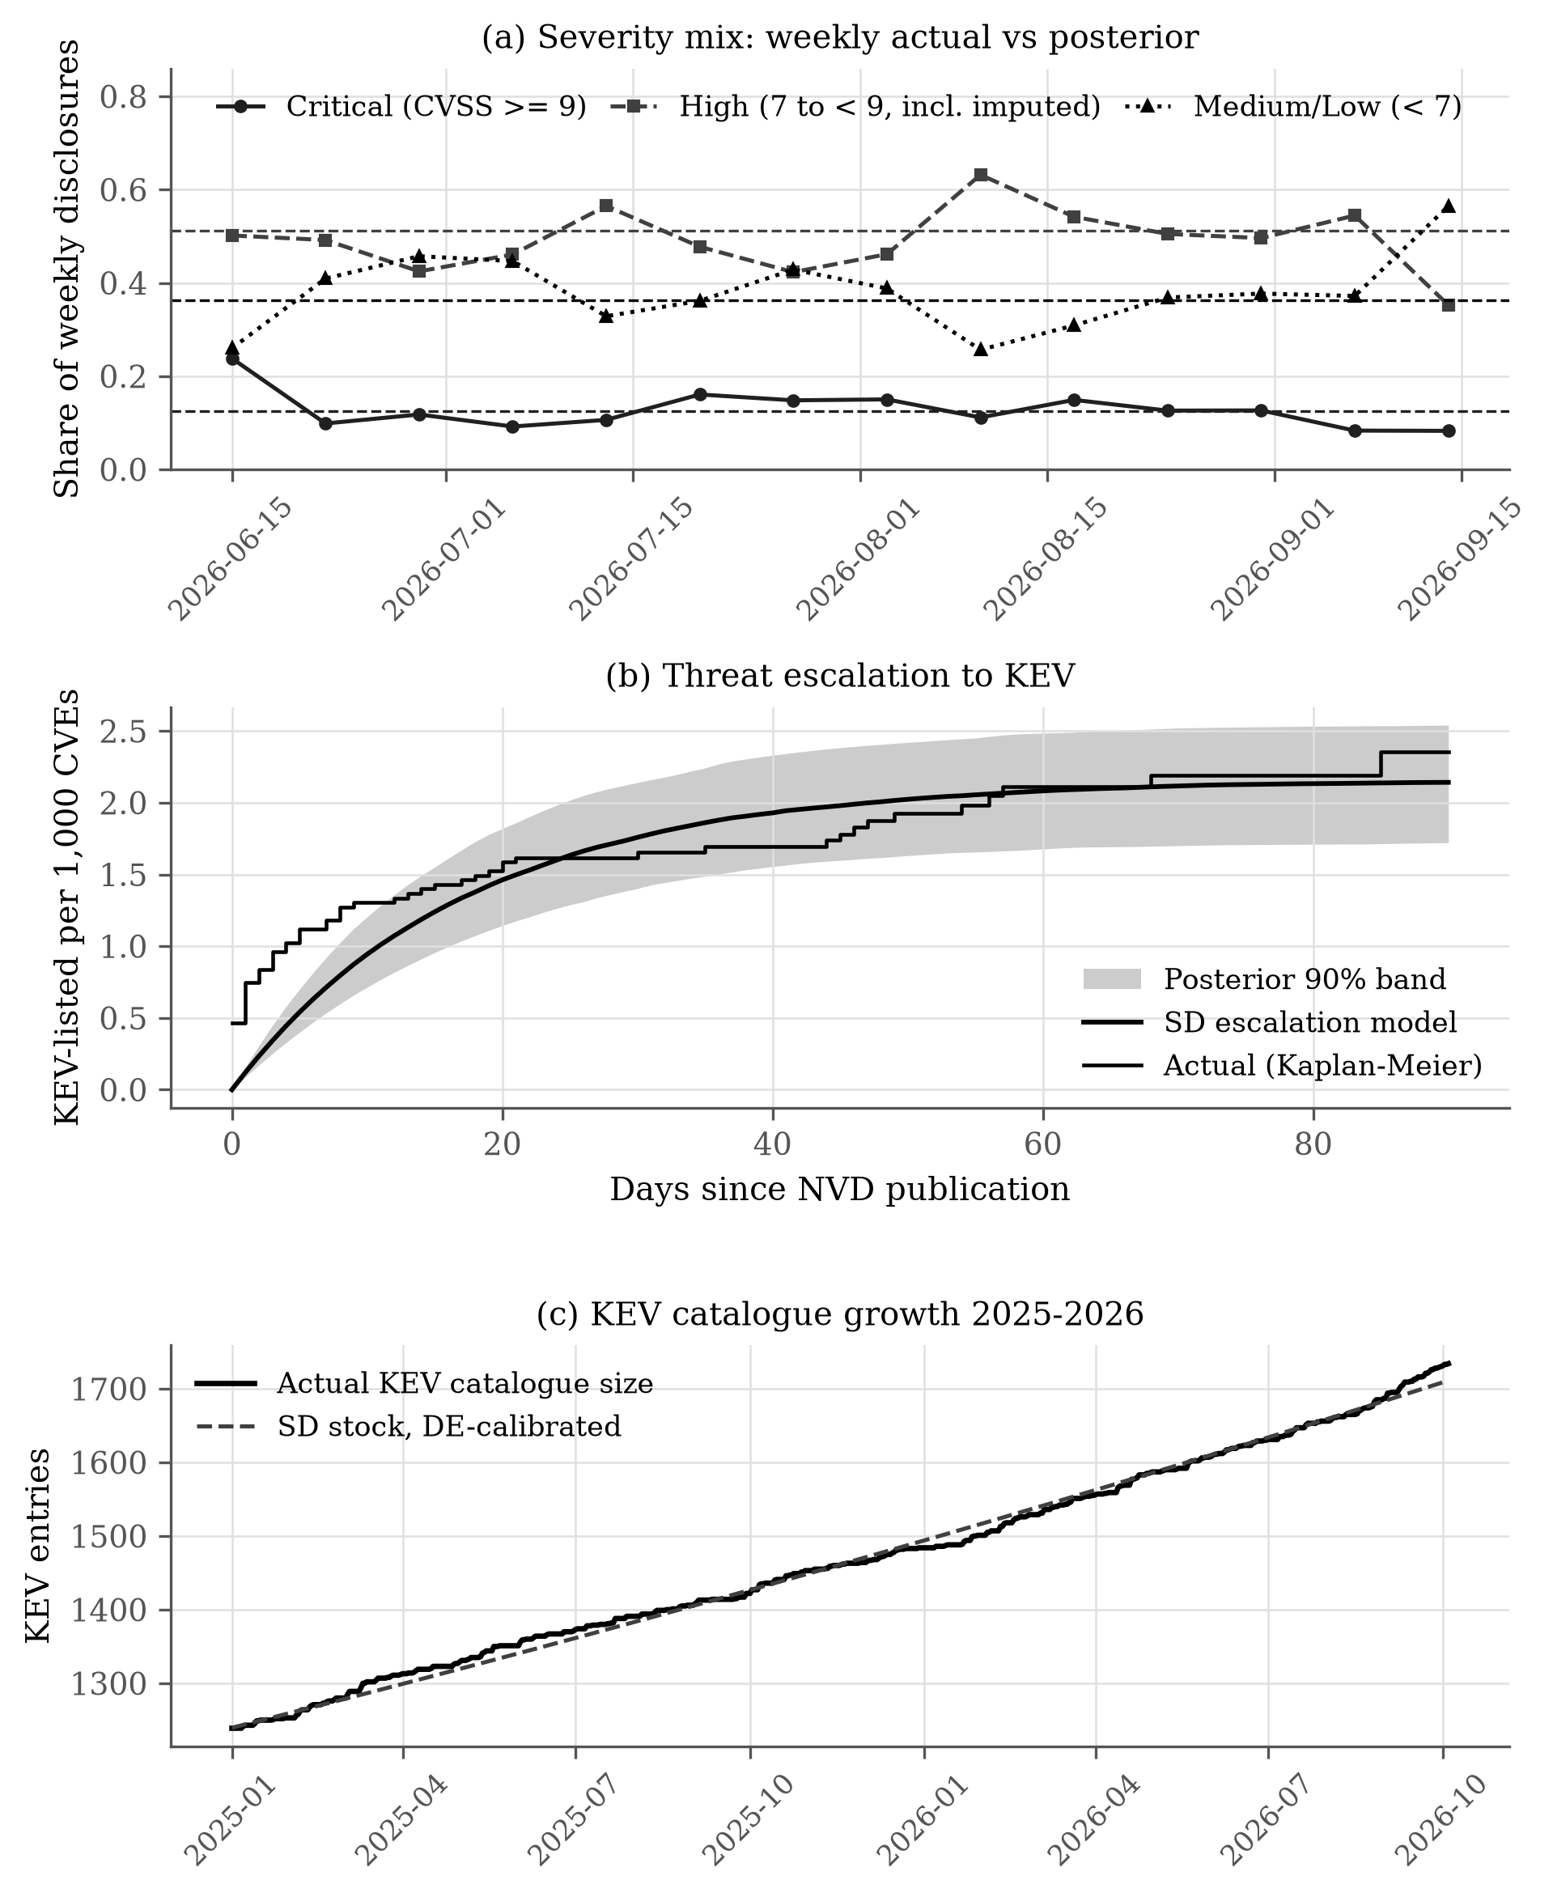
Note. (a) Actual weekly severity shares: critical (circles, solid line), high (squares, dashed line), and medium or low (triangles, dotted line); the horizontal dashed lines are the posterior means. (b) Actual Kaplan–Meier cumulative KEV listing (step line) and the calibrated escalation model (smooth line) with its 90 percent posterior band (grey). (c) Actual KEV catalog size (solid line) and the DE-calibrated System Dynamics stock (dashed line).
Source: NVD records (National Institute of Standards and Technology, n.d.; snapshot of Fraunhofer FKIE CAD, n.d.); CISA KEV catalog revisions (Cybersecurity and Infrastructure Security Agency, n.d.); computed with thesis_sd/src/03_calibrate_severity_kev.py (results/calibration_severity_kev.json).
Figure A2
Calibration of the Remediation Outflow Against Published Remediation Data
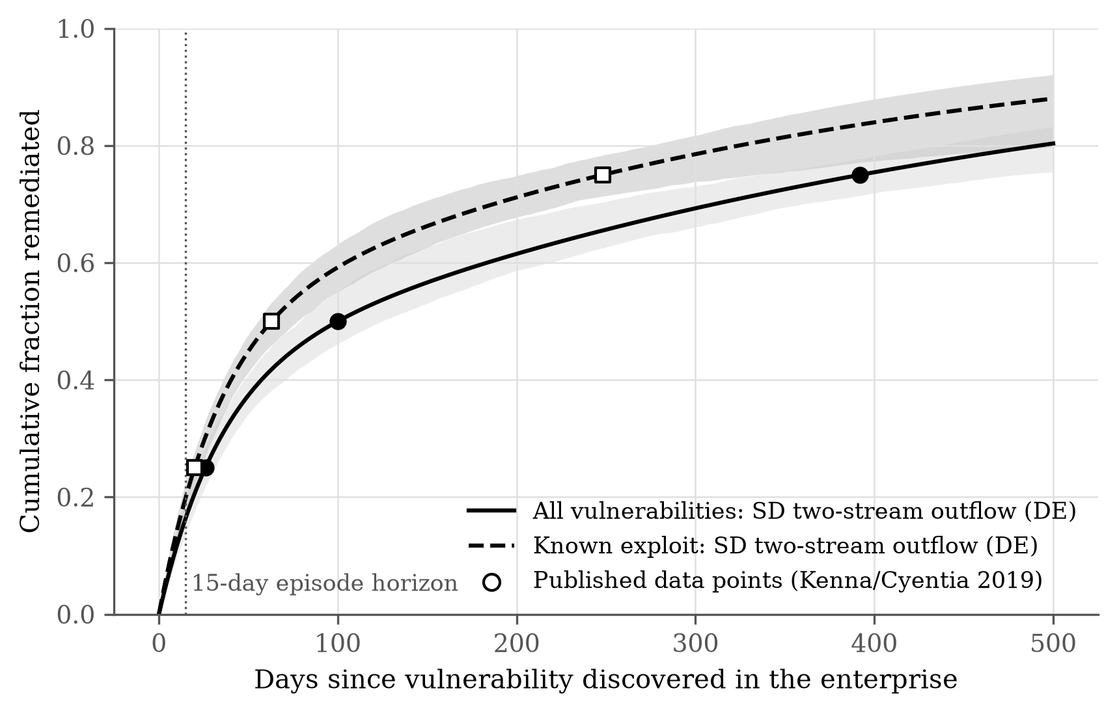
Note. Points are the published remediation milestones (Kenna Security and Cyentia Institute, 2019): filled circles for all vulnerabilities and open squares for known-exploited vulnerabilities. The solid and dashed lines are the corresponding DE-calibrated two-stream outflows, and the grey bands are 90 percent posterior intervals. The dotted vertical line marks the 15-day episode horizon.
Source: published remediation milestones (Kenna Security and Cyentia Institute, 2019); computed with thesis_sd/src/04_calibrate_remediation.py (results/calibration_remediation.json).
Figure A3
Calibrated System Dynamics Runs: Actual Disclosure Stream and Original-Versus-Calibrated Comparison
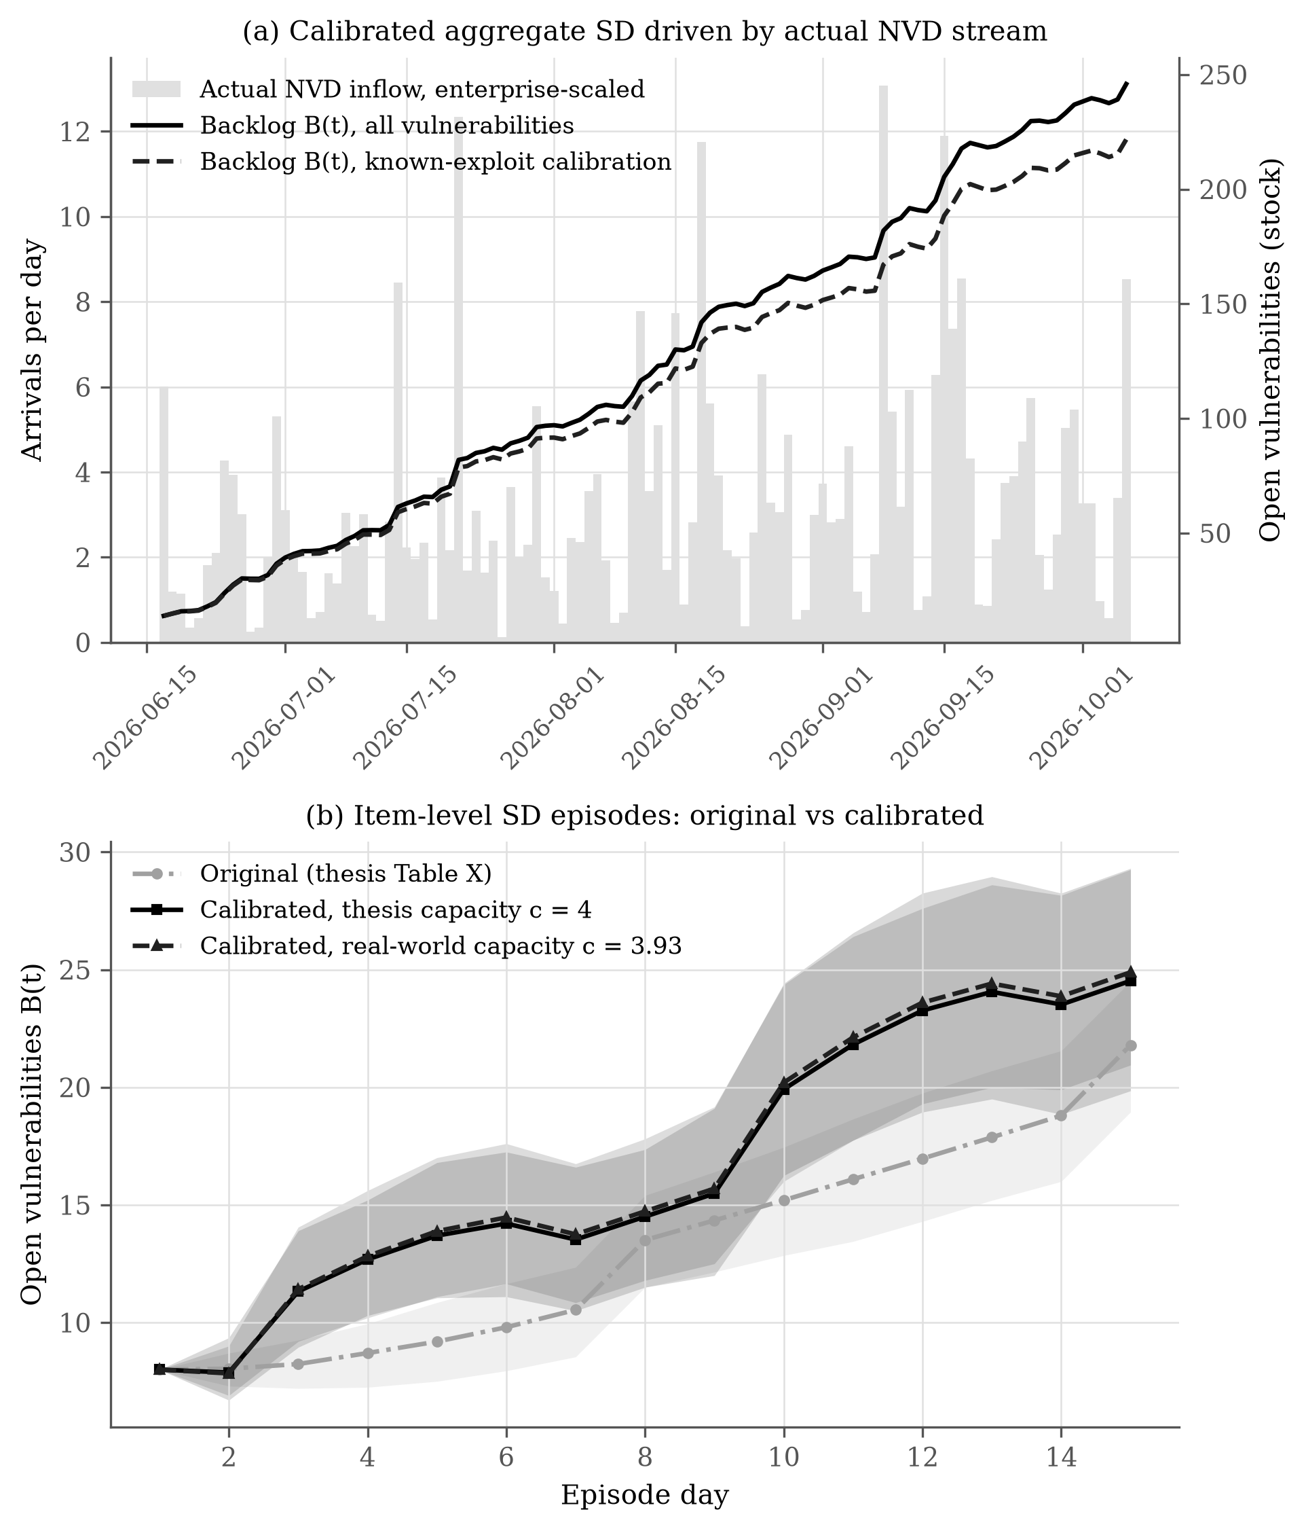
Note. (a) Actual enterprise-scaled NVD inflow (grey bars) and the resulting backlog of the calibrated aggregate model for all vulnerabilities (solid line) and for the known-exploit calibration (dashed line). (b) Mean backlog of the item-level model under the original parameters (dash-dot line, circles), the calibrated parameters with capacity 4 (solid line, squares), and the calibrated capacity (dashed line, triangles), each with a 90 percent band (grey).
Source: NVD records (National Institute of Standards and Technology, n.d.; snapshot of Fraunhofer FKIE CAD, n.d.); computed with thesis_sd/src/05_run_and_compare.py (results/run_and_compare.json).

A5. Model Validation Tests
Table A.13 lists every structural and behavioural validation test of the model and its result.
Table A.13
Model Validation Checks
Validation Test | Method | Result
Stock-flow conservation | Backlog at the end equals arrivals minus patches at every step (automated test 1); 798,720 Sobol episodes of the reference model | Passed — zero conservation error
Determinism | Same seed gives the same results (test 10); complete independent rerun of the study | Passed — 425 of 425 result files byte-identical
Bounds and feasibility | Availability within [0.6, 1], capacity and queue limits at every step in all five conditions (tests 2–3) | Passed
Extreme condition (zero capacity) | No patching for 15 days (test 4) | Passed — backlog equals initial backlog plus all arrivals
Extreme condition (doubled threat) | Threat multiplier doubled (Twin-Testing threat condition) | Passed — exposure increased for every policy (Table XI)
Feedback sign | Lower availability gives lower capacity (tests 5–6) | Passed
Reward decomposition | Named reward terms sum to the reward (test 7) | Passed — exact to 12 decimal places
Prior and placebo identities | SD-only takes the highest prior preference; the placebo ignores the prior; the residual stays within ±2 (test 8) | Passed
No look-ahead | No item published after its decision day; partitions disjoint (test 9) | Passed
Constraint enforcement | All 14,100 test trajectories | Passed — zero violations
Behavior reproduction (historical fit) | Theil decomposition against actual NVD and KEV trends | Passed — bias share at most 0.21; cumulative R-squared at least 0.996
Out-of-sample prediction | 90% posterior predictive band, 22 held-out days | Passed — 22 of 22 days inside the band
Independent statistic | Implied monthly remediation capacity against the published 1 in 10 | Passed — 10.6% against about 10%
Vensim cross-check | Vensim model run with PySD against the reference-model mean (Table A.23) | Passed — availability within 0.74%, total patches within 1.1%
Source: Validation tests after Barlas (1996); thesis_sd/results/sobol_indices.json and thesis_rl_study/tests/test_model.py.

A6. Reinforcement-Learning Configuration
Table A.14 gives the PPO settings used for every learned agent.
Table A.14
PPO Configuration
Setting | Value
Networks | Actor 96-32-35, critic 96-32-1, one hidden layer of 32 tanh units (NumPy)
Budget per agent | 9,600 transitions (40 updates of 16 episodes of 15 days)
Discount γ, GAE λ | 0.99, 0.95
Clip ratio, epochs | 0.2; at most 8, early stop when mean $KL>0.02$
Minibatch | 128, advantages normalised per minibatch
Learning rates (Adam) | Actor 0.0003, critic 0.001
Entropy coefficient, gradient-norm limit | 0.01, 0.5
Seeds | 30 fixed seeds (11, 23, 37, …, 1033); trace seeds 2000–2029 (validation) and 4000–4029 (test)
Source: PPO (Schulman et al., 2017; introduction in Hellgren and Lindgren, 2026) and GAE (Schulman et al., 2016); action masking after Huang and Ontañón (2020); configuration in thesis_rl_study/hybrid_vm/ppo.py.

A7. Additional Results
Figure A4 shows the Twin-Testing results of Table XI as a chart, and Table A.15 gives the validation exposure at the four training budgets of Experiment 3.
Figure A4
Cumulative Exposure by Policy and Condition With 95% Bootstrap Intervals
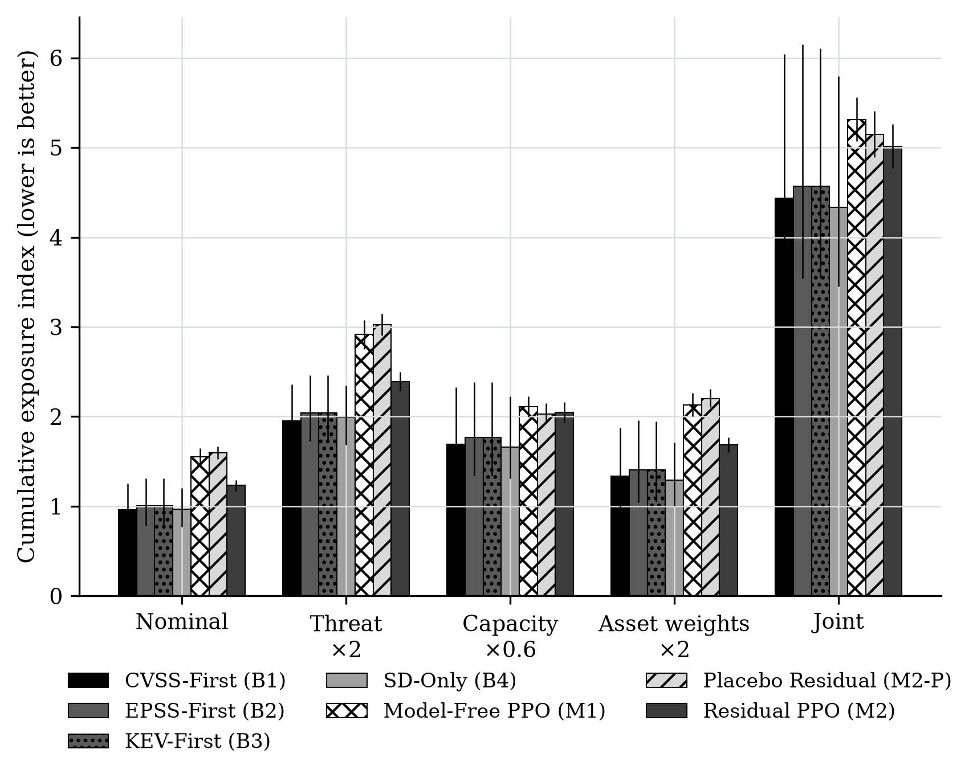
Source: computed with thesis_rl_study/analysis.py (results/twin_summary.csv); bootstrap intervals (Efron and Tibshirani, 1993).
Table A.15
Validation Exposure Along the Training-Budget Ladder (15 Seeds per Arm)
Training transitions | Model-free PPO (M1) | Residual PPO (M2)
9,600 | 1.033 | 0.982
24,000 | 0.955 | 0.903
48,000 | 0.948 | 0.942
96,000 | 0.947 | 0.930
Note. Validation period August 2–16, 2026, 30 traces. References: SD-only 0.888, CVSS-first 0.830.
Source: computed with thesis_rl_study/run_study.py e3 and analysis.py (results/e3_curves.csv, results/e3_ladder.csv).

A8. Sensitivity and Trade-off Results

Table A.16 lists the Sobol indices behind Figure 9 (26,624 parameter vectors × 30 episodes). Table A.17 lists the Pareto-efficient configurations of the SD decision rule behind Figure 10, and Table A.18 the Pareto dominance check among the seven policies of Chapter VI (Figure A5).

Table A.16
Sobol Indices (First-Order / Total-Order) by Trade-off Objective
Parameter | Exposure | Delay | Availability loss
Arrival rate λ | 0.139 / 0.214 | 0.138 / 0.216 | 0.094 / 0.121
Capacity c | 0.030 / 0.059 | 0.469 / 0.532 | 0.004 / 0.021
Threat multiplier h | 0.172 / 0.272 | 0.019 / 0.047 | 0.147 / 0.190
Asset-weight scale | 0.170 / 0.277 | 0.000 / 0.018 | 0.145 / 0.193
Recovery α | 0.000 / 0.008 | 0.002 / 0.015 | 0.047 / 0.062
Patch disruption β₁ | 0.000 / 0.009 | 0.005 / 0.042 | 0.022 / 0.033
Exposure disruption β₂ | 0.001 / 0.009 | 0.001 / 0.017 | 0.131 / 0.194
Initial backlog B₀ | 0.032 / 0.067 | 0.251 / 0.300 | 0.051 / 0.080
Arrival dispersion k | 0.000 / 0.009 | 0.000 / 0.014 | 0.002 / 0.007
Mean threat score | 0.245 / 0.378 | 0.005 / 0.029 | 0.252 / 0.315
KEV hazard η | 0.000 / 0.008 | 0.000 / 0.013 | 0.000 / 0.007
Sum of first-order | 0.778 | 0.887 | 0.893
Source: Saltelli et al. (2010); Herman and Usher (2017); computed with thesis_sd/src/07_sobol.py (results/sobol_indices.json).

Table A.17
Pareto-Efficient Configurations of the System Dynamics Decision Rule (Exposure–Availability Plane)
Capacity | ωA | Budget u | Exposure | Delay | Availability loss
$c=4$ | 5 | 0.875 | 2.295 | 8.04 | 0.0516
$c=4$ | 2 | 0.500 | 2.281 | 7.45 | 0.0574
$c=4$ | 2 | 0.750 | 1.662 | 5.72 | 0.0600
$c=4$ | 2 | 1.000 | 1.505 | 5.23 | 0.0610
$c=4$ | 0.5 | 0.875 | 1.452 | 5.04 | 0.0639
$c=4$ | 1 | 1.000 | 1.302 | 4.35 | 0.0655
$c=3.93$ | 5 | 0.875 | 2.295 | 8.04 | 0.0516
$c=3.93$ | 2 | 0.500 | 2.281 | 7.45 | 0.0574
$c=3.93$ | 2 | 0.750 | 1.682 | 5.76 | 0.0596
$c=3.93$ | 2 | 1.000 | 1.529 | 5.32 | 0.0608
$c=3.93$ | 0.5 | 0.875 | 1.453 | 5.04 | 0.0639
$c=3.93$ | 1 | 1.000 | 1.325 | 4.44 | 0.0653
Source: computed with thesis_sd/src/08_pareto.py (results/pareto.json).

Table A.18
Pareto Dominance Among the Seven Policies
Policy | Non-dominated (nominal exposure, delay) | Non-dominated (five-condition exposure)
CVSS-First (B1) | Yes | Yes
EPSS-First (B2) | No | No
KEV-First (B3) | No | No
SD-Only (B4) | No | Yes
Model-Free PPO (M1) | No | No
Placebo Residual (M2-P) | No | No
Residual PPO (M2) | No | No
Source: computed with thesis_sd/src/08_pareto.py (results/pareto.json).
Table A.19
Twin-Testing Scenarios and Their Principal Trade-offs
Scenario | Lowest-exposure policy | Exposure range (7 policies) | Delay, rule-based (days) | Availability loss range | Principal trade-off
Nominal ($h=1$, full capacity, nominal weights) | CVSS-First | 0.964–1.595 | 5.27 | 0.115–0.117 | —
Threat stress (threat multiplier doubled) | CVSS-First | 1.954–3.022 | 5.55 | 0.116–0.122 | Exposure +103% vs nominal best; delay +0.28 days; availability loss +1% for full-capacity rules
Capacity stress (capacity $×0.6$) | SD-Only | 1.657–2.108 | 7.38 | 0.062–0.064 | Exposure +72% vs nominal best; delay +2.11 days; availability loss -46% for full-capacity rules
Asset stress (every third item's weight doubled) | SD-Only | 1.294–2.201 | 5.27 | 0.117–0.120 | Exposure +34% vs nominal best; delay +0.00 days; availability loss +2% for full-capacity rules
Joint stress (all three shifts) | SD-Only | 4.332–5.313 | 7.38 | 0.078–0.083 | Exposure +349% vs nominal best; delay +2.11 days; availability loss -32% for full-capacity rules
Note. Values from Table XI and the full Twin-Testing results (results/twin_summary.csv). Every stress raises exposure for all policies; capacity and joint stress also lengthen delay, because fewer patches fit into each day, while availability loss falls because less patching disrupts less. No policy is best on all three objectives in every scenario.
Source: computed with thesis_rl_study/analysis.py (results/twin_summary.csv).

Principles drawn from these scenarios: (1) Exposure and availability trade off only along the Pareto frontier; points inside it, including the thesis rule, can be improved on every objective at once. (2) Capacity, not prioritization, is the dominant lever on delay (Sobol total-order index 0.38). (3) A structured prior converts reinforcement learning from a trade-off into a Pareto improvement over unconstrained learning. (4) Robustness must be judged under the shifts that dominate output variance — threat intensity and asset weighting — which are exactly the shifts used in Twin-Testing.
Figure A5
Nominal Exposure and Delay of the Seven Policies (Diamonds: Non-Dominated)
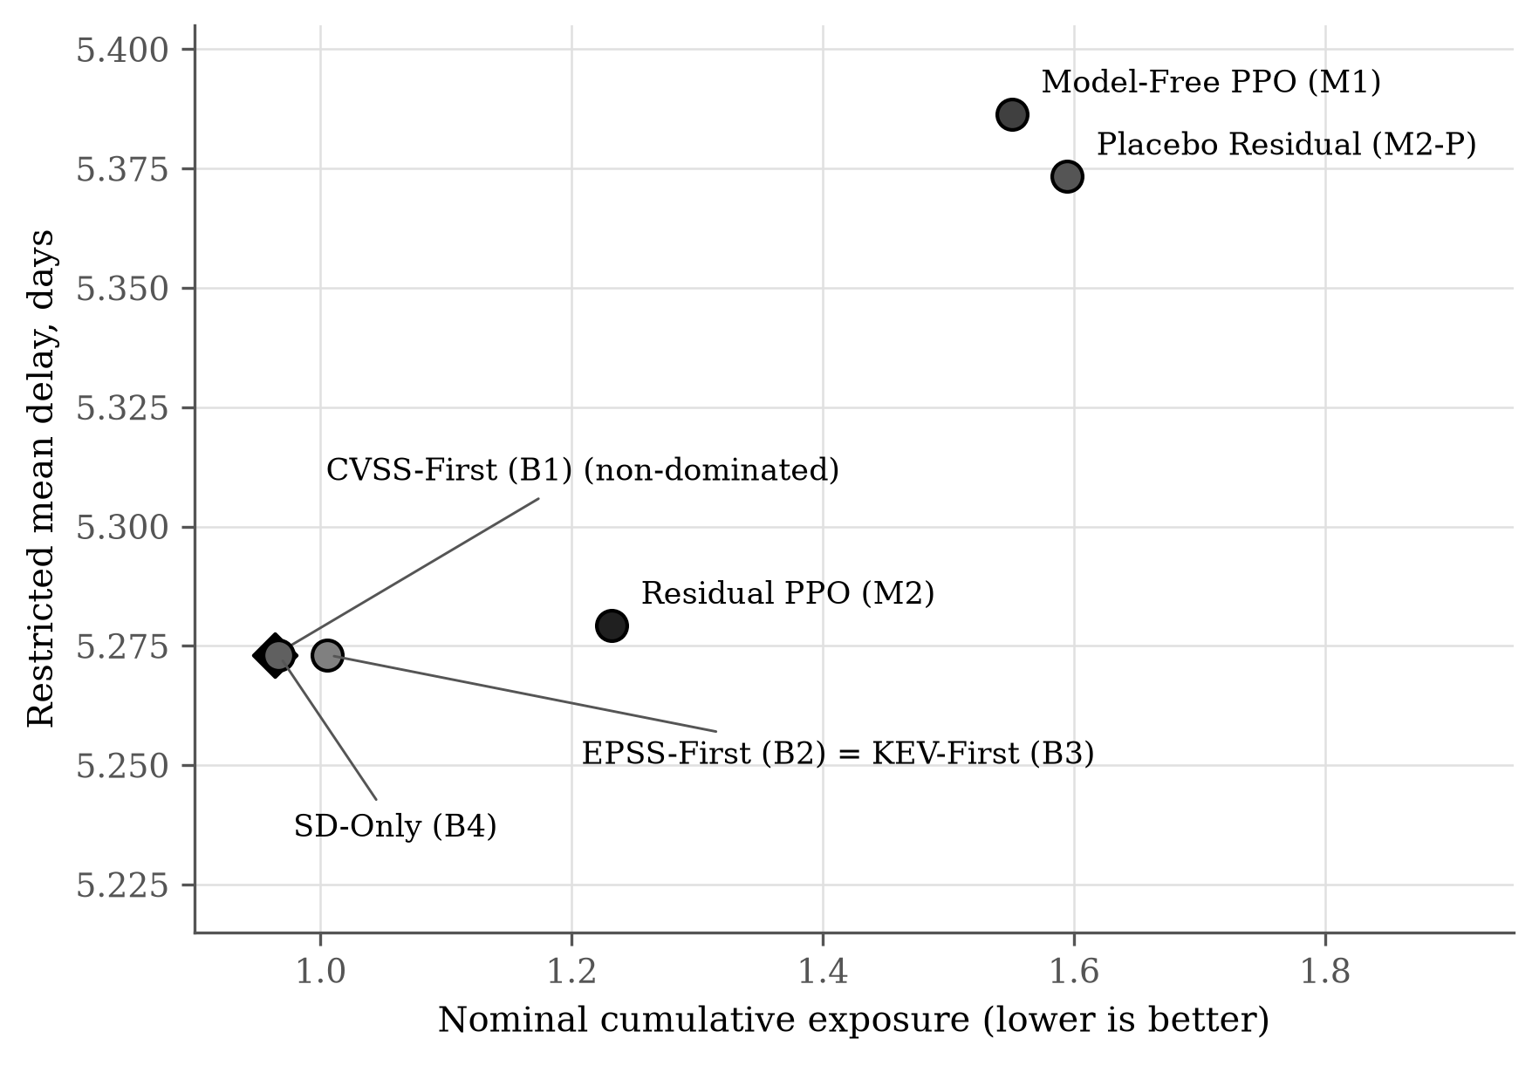
Source: computed with thesis_sd/src/08_pareto.py (results/pareto.json), from the Twin-Testing summary (thesis_rl_study/results/twin_summary.csv).

A9. Reproduction Protocol

Every result in this thesis can be regenerated from two packages, available at the link in Section §A11. The System Dynamics package (thesis_sd) reproduces all calibration, sensitivity and Pareto results with ./run_all.sh and checks them against the reference results with ./verify.sh. The reinforcement-learning package (thesis_rl_study) reproduces every policy, test and statistic in Chapter VI with ./run_all.sh followed by python3 analysis.py, in roughly one hour on one CPU core.

Table A.20
Software Environment
Component | Version | Role
Python | 3.12 | All analysis code
NumPy | 2.5.3 | Simulation kernel
SciPy | 1.18.1 | Differential evolution (Virtanen et al., 2020)
pandas | 3.0.5 | Data extraction
emcee | 3.1.6 | Bayesian MCMC (Foreman-Mackey et al., 2013)
SALib | 1.6.0 | Sobol design and indices (Herman and Usher, 2017)
Matplotlib | 3.11.2 | Figures
pandoc | 3.1.3 | LaTeX to native Word equations
python-docx | 1.2.0 | Thesis document assembly
PySD | 3.14.3 | Vensim model check (separate environment; Table A.23)
Source: Software versions pinned in requirements.txt and the Dockerfiles of both packages.

Table A.21
Pipeline Stages, Inputs, and Outputs
Stage (src/) | Input | Output | Run Time
01_extract_nvd.py | NVD feed snapshot (CVE-2025, CVE-2026 folders) | data/nvd_2026_window.csv | about 2 min
02_calibrate_arrivals.py | nvd_2026_window.csv | calibration_arrivals.json; Figure 4 | about 1 min
03_calibrate_severity_kev.py | NVD CSV; kev_catalog.json | calibration_severity_kev.json; Figure A1 | < 1 min
04_calibrate_remediation.py | remediation_literature.csv | calibration_remediation.json; Figure A2 | < 1 min
05_run_and_compare.py | Stages 2–4 results | run_and_compare.json; Figure A3 | about 3 min
06_diagrams.py | — | Figure 1, 2 and 3 | < 1 min
07_sobol.py | Calibrated parameters | sobol_indices.json; Figure 9; Table A.16 | about 6 min
08_pareto.py | Calibrated parameters; Twin-Testing summary (data/rl_twin_summary.csv) | pareto.json; Figure 10 and Figure A5; Tables A.17–A.18 | about 1 min
09_vensim_pysd_check.py | vensim/vulnerability_sd_model.mdl | vensim_pysd_check.json; Table A.23 | < 1 min (requires PySD)
sdmodel.py | — | Reference SD model (Section §A2 equations) | Library
Source: thesis_sd/run_all.sh and its stage scripts.

The reinforcement-learning package contains ten automated checks, all of which pass: stock conservation, availability bounds and action feasibility, rejection of infeasible actions, the zero-capacity extreme condition, capacity at the availability floor, the sign of the availability-capacity feedback, exact decomposition of the reward, the identities of the SD prior and the placebo, absence of look-ahead, and determinism across repeated runs. All random seeds are fixed (master seed 20261007 for the System Dynamics package; 30 fixed training seeds and trace seeds 2000–2029 and 4000–4029 for the reinforcement-learning package), and checkpoint hashes were recorded before the test window was opened.

Table A.22
Traceability: Thesis Results, Code and Result Files
Thesis item | Produced by | Result file
Figures 1–3 | thesis_sd/src/06_diagrams.py | figs/fig11, fig12
Figure 4 and Figures A1–A2; Tables A.6–A.9 | thesis_sd/src/02–04_calibrate_*.py | results/calibration_*.json
Figure A3; Table A.12, D5 | thesis_sd/src/05_run_and_compare.py | results/run_and_compare.json
Figure 9; Table A.16 | thesis_sd/src/07_sobol.py | results/sobol_indices.json
Figure 10 and Figure A5; Tables A.17–A.18 | thesis_sd/src/08_pareto.py | results/pareto.json
Reference scales (Table A.5) | thesis_rl_study/run_study.py scales | results/reference_scales.json
Table XI; Figure A4 | run_study.py twin; analysis.py | results/twin/test_results.csv, twin_summary.csv
Table XII; Figure 5 | analysis.py | results/table_XVII_ablation.csv
Figures 6–7 | run_study.py e2; analysis.py | results/e2.csv, e2_summary.csv, e2_repair_ratio.csv
Table A.15; Figure 8 | run_study.py e3; analysis.py | results/e3_curves.csv, e3_ladder.csv
Table XIII | analysis.py | results/confirmatory_tests.json
Table XIV | VARIANT=balanced run_study.py twin; analysis_balanced.py | results_balanced/comparison.csv
Vensim model check (Table A.23) | thesis_sd/vensim/vulnerability_sd_model.mdl; src/09_vensim_pysd_check.py (PySD) | results/vensim_pysd_check.json
Source: File paths refer to the two archived packages.
Table A.23
Vensim Model Run With PySD Against the Mean of 4,000 Reference-Model Episodes
Day | Backlog (Vensim) | Backlog (reference mean) | Availability (Vensim) | Availability (reference mean) | Patches (Vensim) | Patches (reference mean)
1 | 8.00 | 8.00 | 0.9836 | 0.9836 | 3.0 | 3.00
5 | 8.00 | 9.11 | 0.9396 | 0.9442 | 2.0 | 2.39
7 | 10.00 | 10.40 | 0.9364 | 0.9403 | 0.0 | 0.00
10 | 15.00 | 15.10 | 0.9150 | 0.9189 | 2.0 | 2.11
14 | 19.00 | 18.74 | 0.8982 | 0.9044 | 0.0 | 0.00
15 | 22.00 | 21.75 | 0.8904 | 0.8971 | 2.0 | 2.05
Note. Original parameters, deterministic arrivals of three per day in the Vensim model. Days 7 and 14 are maintenance closures. Produced by thesis_sd/src/09_vensim_pysd_check.py (results/vensim_pysd_check.json).
Source: Vensim model thesis_sd/vensim/vulnerability_sd_model.mdl run with PySD; computed with thesis_sd/src/09_vensim_pysd_check.py (results/vensim_pysd_check.json).

A10. Guide to Tables and Figures
This appendix explains every table and figure in the thesis: what it shows, including the meaning of every line, marker, band and bar, which data and source it is based on, and why that form of presentation was chosen. Tables are used where the reader needs exact values or definitions; figures are used where a pattern, trend, uncertainty, structure or trade-off must be seen. Each figure has a companion table holding its exact values (Table A.22 lists the code and result file behind each item). All figures are monochrome: series are distinguished by line style, marker and hatching.
Table A.24
Guide to the Tables
Table | What it shows | Data and source | Why this form
Table I | Each research question with its objective and the evidence that answers it | Research design of this thesis | Table: three questions compared on the same three attributes
Table II | The four public data sources: what each contains, how it is used, its main limitation | NVD, EPSS, CISA KEV and HHS-OCR providers (Table A.4) | Table: side-by-side comparison of sources on the same attributes
Table III | Five literature streams: what each established and which gap this thesis addresses | Studies cited in Chapter II | Table: compares text across streams, which a chart cannot show
Table IV | Formal definition of state, action, reward, constraints and horizon | Formulation of Chapter III; Altman (1999); Achiam et al. (2017) | Definition table: precise wording for each model element
Table V | The seven policies: decision rule, whether learned, whether the SD prior is used | Design of Chapter III | Table: yes or no attributes per policy are read most clearly in rows
Table VI | Every outcome measure, how to interpret it and which question it serves | Equations (A.14)–(A.17) | Definition table
Table VII | The four pre-registered hypotheses and their statistical tests | Pre-registration; Wilcoxon (1945); Holm (1979) | Table: one row per hypothesis for exact statements
Table VIII | Each validity threat, its control and the remaining limitation | Assessment in Chapters III and VII | Table: three-part reasoning per threat
Table IX | Calendar dates and purpose of training, validation, retired and test windows | Data panel dates | Table: exact dates must be read, not estimated from a timeline
Table X | Every SD parameter: original value, calibrated value with 95% interval, data and method | Calibration results (Section §A4) | Table: exact estimates and intervals
Table A.11 | Goodness of fit of each calibrated sub-model (R-squared, RMSE, MAPE, Theil components) | Calibration results; Sterman (1984) | Table: several statistics per sub-model; Figure 4 and Figures A1–A2 show the fits visually
Table A.12 | Reference SD model outputs under original and calibrated parameters with 95% intervals | run_and_compare.json | Table: exact means and intervals for six outputs; Figure A3 shows the trajectories
Table A.13 | Every validation test, its method and its result | Automated tests and reference-model checks | Checklist table
Table A.14 | PPO settings used for every learned agent | Schulman et al. (2016, 2017); ppo.py | Settings table for exact reproduction
Table XI | Cumulative exposure of the seven policies in the five conditions | Twin-Testing results | Table for exact values; Figure A4 shows the same data as a chart
Table XII | E1 ablation: exposure, delay, residual size and effect relative to M2 | Twin-Testing results, nominal condition | Table: four attributes per policy; Figure 5 shows the spread
Table A.15 | Validation exposure of M1 and M2 at the four training budgets | E3 learning curves | Table for exact ladder values; Figure 8 shows the full curves
Table XIII | The four confirmatory tests: difference, interval, effect size, Holm p, decision | confirmatory_tests.json | Table: statistical results must be reported exactly
Table XIV | Exploratory comparison of nominal exposure under two reward weightings | results_balanced/comparison.csv | Table: two numbers per policy
Table A.1 | Where every piece of evidence is located in the research packages | Inventory of the two packages | Inventory table
Table A.2 | Every equation: what it computes, how it is solved, and the code that implements it | Equations of Chapters III–IV and Section §A2; both packages | Reference table: one row per equation group
Table A.3 | Every parameter with its value, source, rationale and test | Literature and data listed in the table | Provenance table
Table A.4 | Every dataset with provider, snapshot, record count and use | Data providers | Provenance table
Table A.5 | Units and empirical or engineering status of every model quantity | Equations (A.1)–(A.17) | Units table for the dimensional-consistency check
Table A.6 | Arrival-model parameters from differential evolution and Bayesian estimation | NVD; calibration_arrivals.json | Table of estimates with 95% credible intervals
Table A.7 | Sampler settings, convergence diagnostics and fit statistics | calibration_arrivals.json | Diagnostics table
Table A.8 | Severity shares and KEV escalation estimates | NVD; KEV; calibration_severity_kev.json | Table of estimates with intervals
Table A.9 | Remediation-model estimates for all and known-exploit vulnerabilities | Kenna and Cyentia (2019); calibration_remediation.json | Table of estimates with intervals
Table A.10 | Capacity calibration target, search and outcome | run_and_compare.json | Table of exact values
Table A.16 | First- and total-order Sobol indices of all eleven parameters | sobol_indices.json | Exact values behind Figure 9
Table A.17 | The Pareto-efficient configurations of the SD rule | pareto.json | Exact values behind Figure 10
Table A.18 | Which policies are Pareto non-dominated | pareto.json | Yes or no table behind Figure A5
Table A.19 | Each test scenario with its best policy and principal trade-off | Twin-Testing summary | Table: combines numbers and a written trade-off per scenario
Table A.20 | Software versions | Pinned requirements and Dockerfiles | Reference table for reproduction
Table A.21 | Each pipeline stage with inputs, outputs and run time | run_all.sh | Reference table for reproduction
Table A.22 | Which code and result file produce each table and figure | Both packages | Traceability table
Table A.23 | Vensim model run with PySD against the reference-model mean | vensim_pysd_check.json | Table of daily values for exact comparison
Source: Data and sources as stated in each table's own Source line.
Table A.25
Guide to the Figures, Including Every Line, Marker, Band, and Bar
Figure | What it shows | Data and source | Why this chart type
Figure 1 | Block diagram: public data, System Dynamics model, seven policies and evaluation design; arrows show the flow of the study | Original design | Block diagram: shows how the parts connect, which a table cannot
Figure 2 | Causal loop diagram. Arrows are causal links with plus or minus polarity; B1 to B5 are balancing loops and R1 the reinforcing emergency-work loop; the dashed arrow is the decision-rule link; grey labels are external drivers | Model equations; Sterman (2000) | System Dynamics convention for showing feedback structure
Figure 3 | Stock-and-flow diagram. Rectangles are the two stocks, valves the flows, clouds the model boundary; dashed arrows are information links | Model equations; Sterman (2000) | System Dynamics convention for stocks and flows
Figure 4 | Top: actual daily NVD disclosures (solid line with points), differential-evolution fit (dash-dot), Bayesian 90% predictive band (grey), posterior mean on the hold-out days (dashed); the dotted vertical line marks the hold-out start. Bottom: the same as cumulative totals | NVD records; calibration_arrivals.json | Line chart: disclosures are a time series; the band shows uncertainty; the hold-out shows out-of-sample accuracy
Figure A1 | (a) Weekly severity shares: critical (circles, solid), high (squares, dashed), medium and low (triangles, dotted), with posterior means as horizontal dashed lines. (b) KEV listing: Kaplan-Meier step curve of the actual data, model curve and 90% band. (c) KEV catalog size: actual (solid) and fitted model (dashed) | NVD; CISA KEV; calibration_severity_kev.json | (a) lines for shares over time; (b) Kaplan-Meier, the standard method for time-to-event data with unlisted items; (c) line for growth over time
Figure A2 | Published remediation milestones as points (filled: all vulnerabilities; open squares: known exploits), fitted curves (solid and dashed), 90% bands, and the 15-day horizon (dotted) | Kenna and Cyentia (2019); calibration_remediation.json | Points for the few published values, continuous lines for the fitted model
Figure A3 | (a) Grey bars: actual daily inflow scaled to one enterprise; lines: resulting backlog (solid: all vulnerabilities; dashed: known exploits). (b) Mean backlog over the episode for original parameters (dash-dot, circles), calibrated with capacity 4 (solid, squares) and calibrated capacity (dashed, triangles), with 5 to 95% bands | run_and_compare.json | (a) bars for daily counts and lines for the accumulating stock; (b) lines with bands to compare average paths and their spread
Figure A4 | Grouped bars: cumulative exposure of the seven policies (grey shades and hatching) in each of the five conditions; error bars are 95% bootstrap intervals | Twin-Testing results | Grouped bar chart: compares groups across conditions
Figure 5 | Bars: mean nominal exposure of M1, M2-P, B4 and M2 with 95% intervals; dots: the 30 individual seeds | Twin-Testing results | Bars with intervals as specified by the thesis committee; dots show the full spread across seeds (Agarwal et al., 2021)
Figure 6 | Exposure against mismatch level. Solid lines: wrong prior with correct environment; dashed lines: shifted environment with nominal prior. Circles: SD-only; squares: model-free PPO; triangles: residual PPO. Left panel: threat scaling; right panel: asset weights | E2 results | Line chart: exposure as a function of mismatch, as specified by the thesis committee
Figure 7 | Residual repair ratio against mismatch level: threat (circles, solid) and asset weights (squares, dashed), with 95% bands; the horizontal line marks zero | e2_repair_ratio.csv | Line chart with a zero reference line, as specified by the thesis committee
Figure 8 | Validation exposure against training transitions on a log scale: model-free PPO (dashed) and residual PPO (solid), each with a band of plus or minus one standard deviation over 15 seeds; reference lines for SD-only (dash-dot) and CVSS-first (dotted) | E3 learning curves | Learning-curve chart as specified by the thesis committee; a log scale suits budgets from 9,600 to 96,000
Figure 9 | Horizontal bars for each of eleven parameters: dark bars are total-order indices, hatched bars first-order indices, with 95% intervals; panels for exposure, delay and availability loss | sobol_indices.json; Saltelli et al. (2010) | Sorted horizontal bars: the standard presentation of Sobol indices
Figure 10 | Seventy configurations of the SD rule (points; shade shows the patch budget), the Pareto frontier (line) and the rule used in this thesis (star), at two capacities | pareto.json | Scatter plot with frontier: the standard way to show a two-objective trade-off
Figure A5 | Nominal exposure against delay for the seven policies; diamonds are non-dominated, circles dominated | pareto.json; Twin-Testing summary | Scatter plot: shows which policies are beaten on both measures
Source: Data and sources as stated in each figure's own Source line.

A11. Code and Data
The complete source code, the as-of data panel, the trained agents and every result file are available at the link below. They are organised in two packages: thesis_rl_study contains the environment, the SD prior, the seven policies, the experiments, the statistics and the tests; thesis_sd contains the reference System Dynamics model, its calibration to public data, the sensitivity and Pareto analyses, and the Vensim model. Section §A9 gives the commands that run them, and Table A.27 lists every source file and its role.
Code and data: [PASTE THE SHARING LINK HERE]
Table A.26 identifies each data and result file by size and SHA-256 fingerprint, so that the files at the link can be checked against those used in this thesis; every number taken from them is reported in the tables of Chapters IV to VI and Section §A4 and §A8.
Table A.26
Data and Result Files With Their SHA-256 Fingerprints
File | Size | SHA-256
thesis_rl_study/panel.npz | 5.7 MB | 2ddb70fa5f98383819ab48d58c2a9f521cc5c97971267487810d02b35ca8dece
thesis_rl_study/results/reference_scales.json | 0.3 kB | 68ea05929cbd4e793cbef71776f0935834fcbbb99524b93ccd4921a422c01a90
thesis_rl_study/results/twin/test_results.csv | 1.9 MB | 525755e379e2a9d3ffcdb6443a3a25002e88d758350542308a75caab8769cc54
thesis_rl_study/results/twin/training_log.csv | 192.3 kB | a8142915a9c1e894e947d70c2f560b1f9ad7263107f957872772d980bd143966
thesis_rl_study/results/twin/checkpoint_manifest_before_test.json | 7.8 kB | be4f005d57530b456fe7685c9e6eef49b912ffdc2987657c9c57c34e95c615cf
thesis_rl_study/results/twin/*.npz (90 trained agents) | 5.5 MB in total | listed individually in checkpoint_manifest_before_test.json
thesis_rl_study/results/twin_summary.csv | 5.0 kB | f733d4fa95d2dfd14d2d4680cdadd0b549ff57c3fbfa3d07be19d0447a3e42df
thesis_rl_study/results/table_XVII_ablation.csv | 0.3 kB | debe3fc7d55b366f5e0746c33812a10c95765c571bf3ec89c8071f2b4090d7c1
thesis_rl_study/results/e2.csv | 2.5 MB | 994f8c899412c1219ed8622433f44e0c24a27a850e54b571f8f9e1ab39b6c33f
thesis_rl_study/results/e2_summary.csv | 2.6 kB | f05236d4ff41303ca540283803f65255025ffeab04eceb4f4baf49ef6fed29bd
thesis_rl_study/results/e2_repair_ratio.csv | 1.0 kB | ec5eaac8299984a8f3221787d39d46bce0f8d87c9b3cd012ce443839c9562e76
thesis_rl_study/results/e3_curves.csv | 21.1 kB | dbf8349e7a73a56b41d9832411c266f000f7aca45c549e4f8ee9f0aff4bb23ec
thesis_rl_study/results/e3_ladder.csv | 0.2 kB | 55fe92337c0dd5a1990fb776295d54eefd42a4eb3376d36ad74d69e549c6f7b6
thesis_rl_study/results/confirmatory_tests.json | 2.0 kB | 62585741ef32c704af2cc6281c8d40db3a105a9484830e324c2dbec0d3925176
thesis_rl_study/results_balanced/comparison.csv | 0.7 kB | f59e0638e0569bc109c4131341101fa8b4cc8a70d54c3d45c64694868f0b6707
thesis_sd/data/kev_catalog.json | 1.8 MB | f51fed1c9213e7b797104fcd6dbeb1b0dc0c7073a80467b9d4b1fc25e7dd786b
thesis_sd/data/nvd_2026_window.csv | 2.4 MB | 392918afb6fb9e9d0673ab91fd4e6f43a3b59bafa7c41eb3a0f828bc077c4162
thesis_sd/data/remediation_literature.csv | 0.6 kB | a673c2a2282883ccd265a872823e5320feba4a8b1b17995b93b214f6abf6e0b4
thesis_sd/data/rl_twin_summary.csv | 5.0 kB | f733d4fa95d2dfd14d2d4680cdadd0b549ff57c3fbfa3d07be19d0447a3e42df
thesis_sd/results/calibration_arrivals.json | 6.1 kB | c9bd2dfa90ba03ce0a1c825781ca9eba87e1dba2ac5908dd21e36dadf773402e
thesis_sd/results/calibration_remediation.json | 3.0 kB | 3adbf463c69828dae773db2e8119fb3e53bce7212291894985f7563b86889e57
thesis_sd/results/calibration_severity_kev.json | 1.8 kB | 3634d2d455c60d6db00064d7a189a247c8822a897b6c424407bbb719d22dc008
thesis_sd/results/pareto.json | 29.4 kB | 65dd6369b6b844732c3fbb90b755a145e33495017dc1439d66f74ca7d3c8893b
thesis_sd/results/run_and_compare.json | 3.6 kB | 20ea6739bce679baa43dc8c110d09520d8caca407219f4892d1af361160c718a
thesis_sd/results/sobol_indices.json | 11.1 kB | 6325f837ed62f8345d195028b04be400a6caa0a3308f18c1c5cd66672e05b5df
thesis_sd/results/vensim_pysd_check.json | 1.5 kB | 84fafad88f43aa7fa0cd67ffac10541bf19faa494e57e1c2222000a1f66f5d55
Source: computed from the files of the two archived packages.
Table A.27
Source Files and Their Role
File | Role | Lines
thesis_rl_study/hybrid_vm/env.py | Environment, observation, SD prior and rule-based policies | 206
thesis_rl_study/hybrid_vm/ppo.py | PPO agents M1, M2 and M2-P | 121
thesis_rl_study/run_study.py | Experiment runner: reference scales, Twin-Testing and E1, E2, E3 | 194
thesis_rl_study/analysis.py | Confirmatory statistics, tables and Figures 5–8 and Figure A4 | 172
thesis_rl_study/analysis_balanced.py | Exploratory reward-weighting analysis (Table XIV) | 27
thesis_rl_study/tests/test_model.py | Automated test suite (ten checks) | 89
thesis_rl_study/verify_rl.py | Byte-for-byte verification of a rerun | 18
thesis_rl_study/run_all.sh | Complete run of the reinforcement-learning study | 16
thesis_rl_study/Dockerfile | Software environment | 11
thesis_sd/src/common.py | Shared settings, plotting style and fit statistics | 29
thesis_sd/src/sdmodel.py | System Dynamics reference model | 112
thesis_sd/src/01_extract_nvd.py | Extraction of the NVD window | 21
thesis_sd/src/02_calibrate_arrivals.py | Calibration of disclosure inflow (Figure 4, Table A.6) | 134
thesis_sd/src/03_calibrate_severity_kev.py | Calibration of severity mix and KEV escalation (Figure A1, Table A.8) | 108
thesis_sd/src/04_calibrate_remediation.py | Calibration of remediation outflow (Figure A2, Table A.9) | 68
thesis_sd/src/05_run_and_compare.py | Capacity calibration and calibrated run (Figure A3, Table A.12) | 105
thesis_sd/src/06_diagrams.py | Figures 1–3 | 114
thesis_sd/src/07_sobol.py | Sobol sensitivity analysis (Figure 9, Table A.16) | 60
thesis_sd/src/08_pareto.py | Pareto analysis (Figure 10 and Figure A5, Tables A.17–A.18) | 90
thesis_sd/src/09_vensim_pysd_check.py | Vensim model check with PySD (Table A.23) | 23
thesis_sd/vensim/vulnerability_sd_model.mdl | Vensim model of the System Dynamics structure | 161
thesis_sd/verify.py | Verification of a rerun against the reference results | 29
thesis_sd/verify.sh | Verification command | 2
thesis_sd/run_all.sh | Complete run of the System Dynamics pipeline | 16
thesis_sd/requirements.txt | Pinned Python packages | 7
thesis_sd/Dockerfile | Software environment | 11
Source: The files are in the two packages available at the link above.

